STEPS FOR CREATING GITHUB :

STEP-1 CREATING GITHUB ACCOUNT
STEP-2 CREATING REPOSITORIES

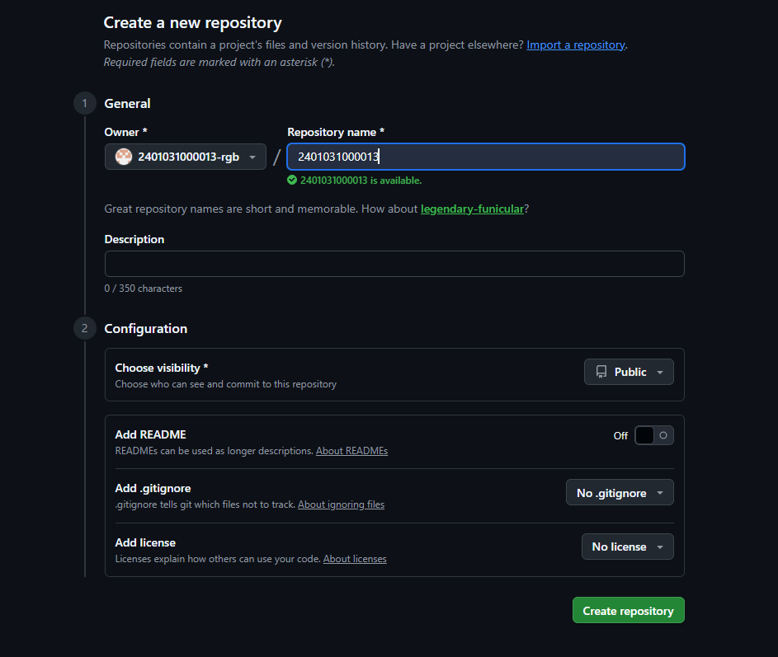

STEP-3 CREATING ASSIGNMENT-1 FOLDER IN REPOSITORY
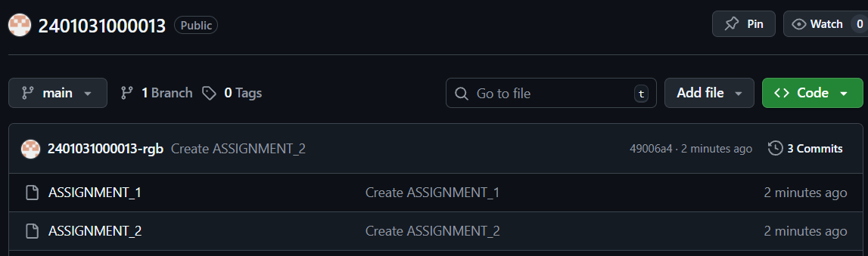

STEP-4 REPOSITORY AND FOLDERS CREATED.

